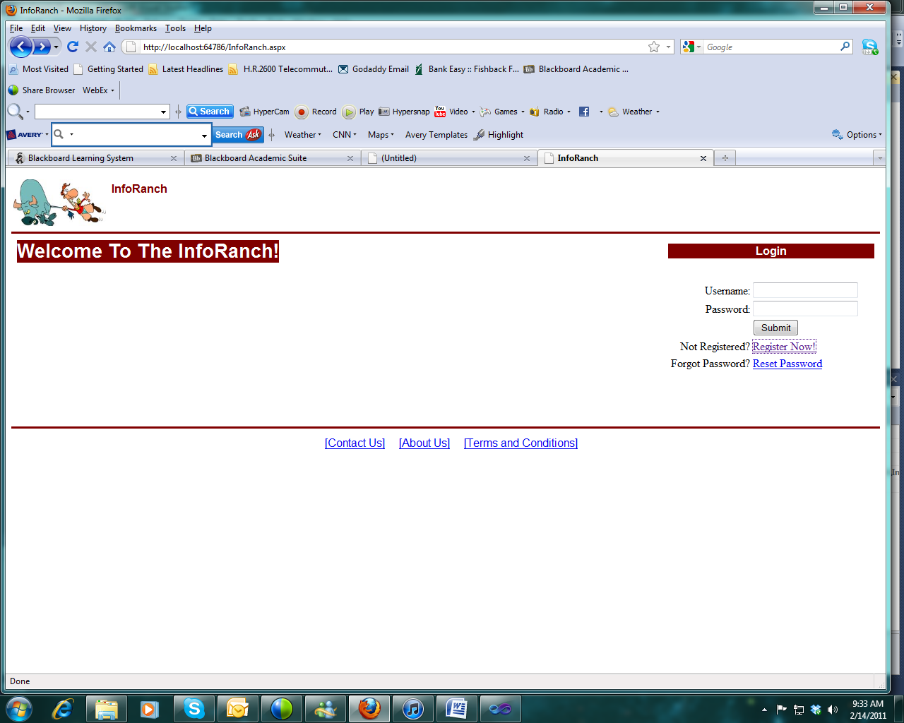

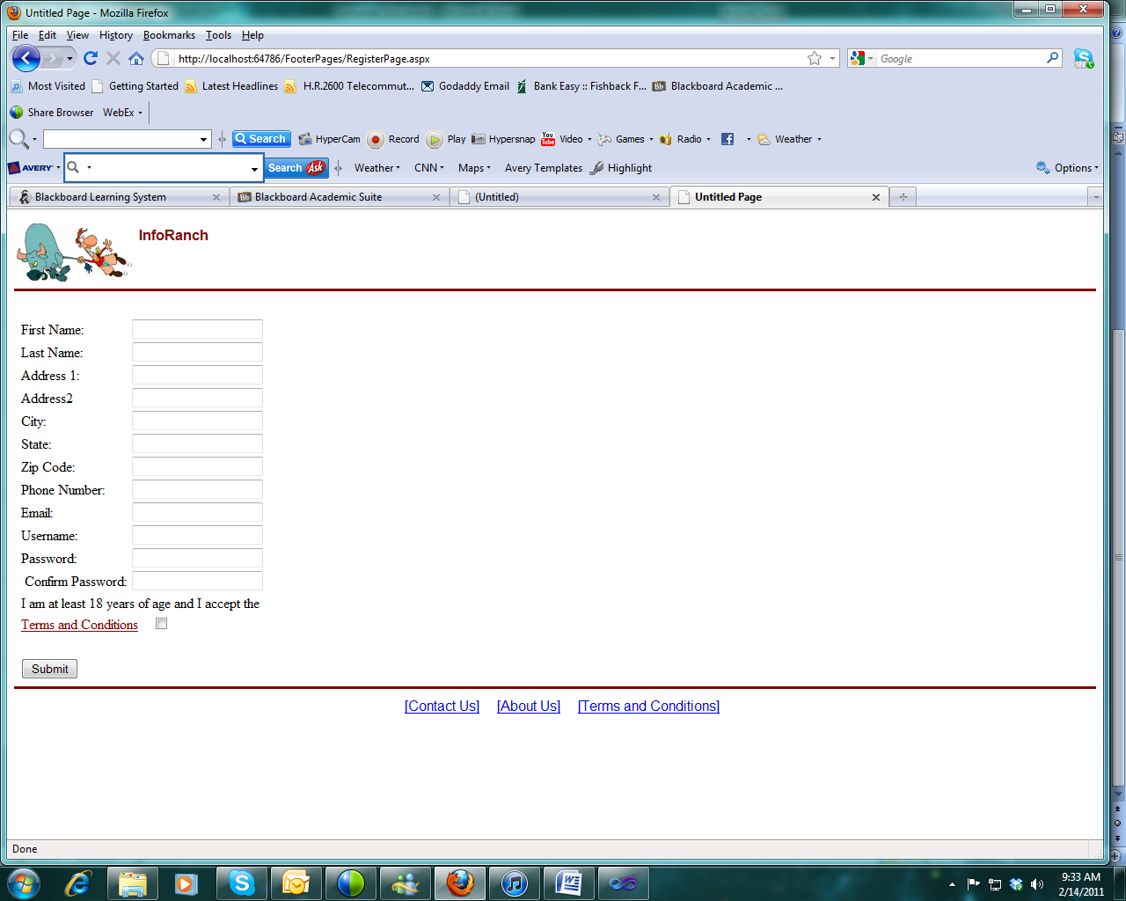

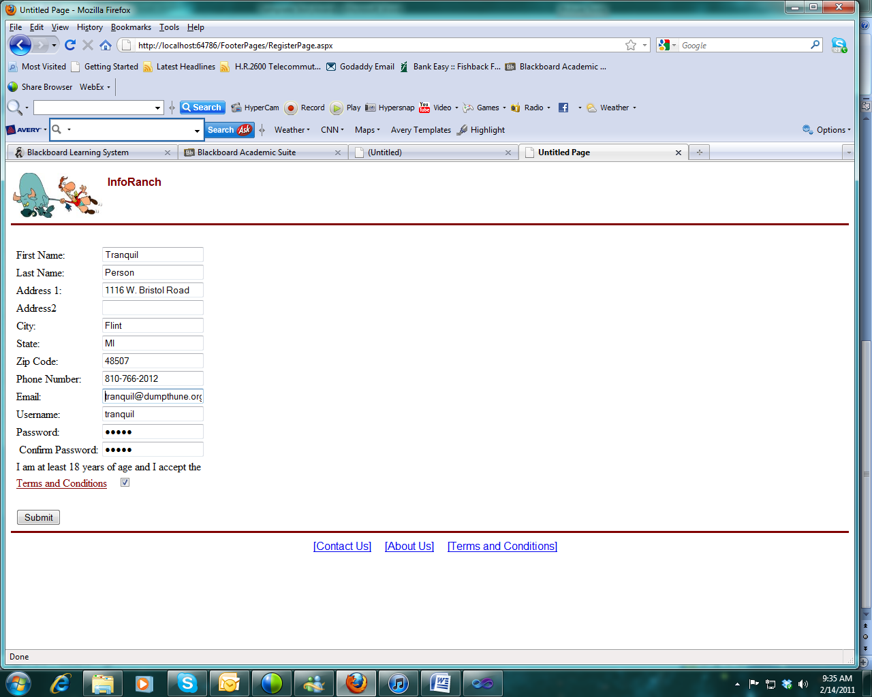

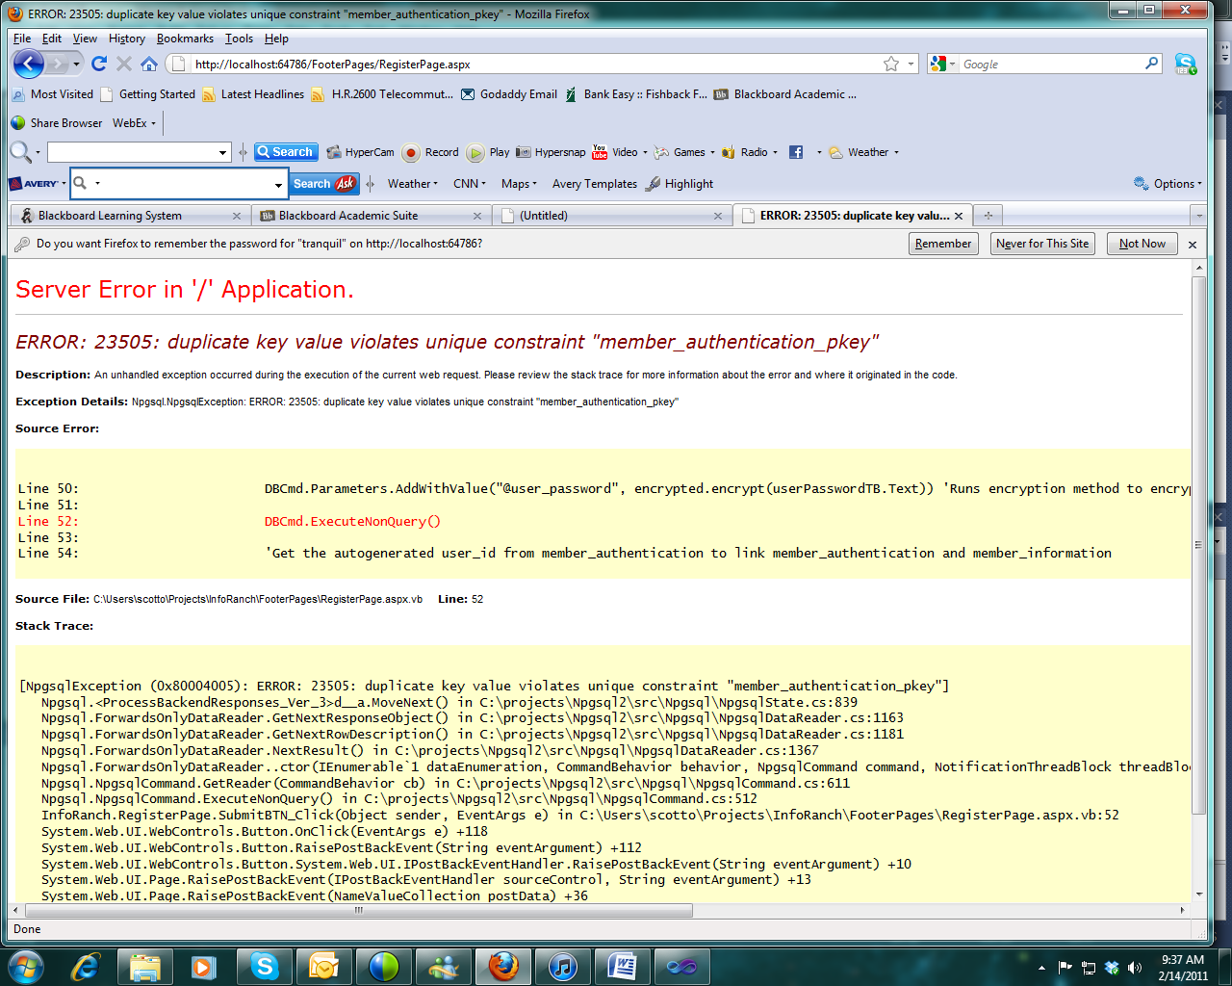

Error in Account Creation

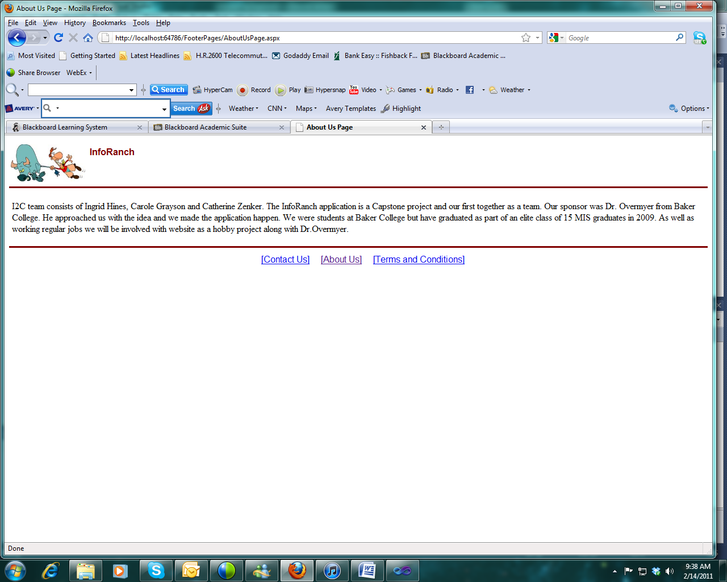

About Us Page (Needs work)

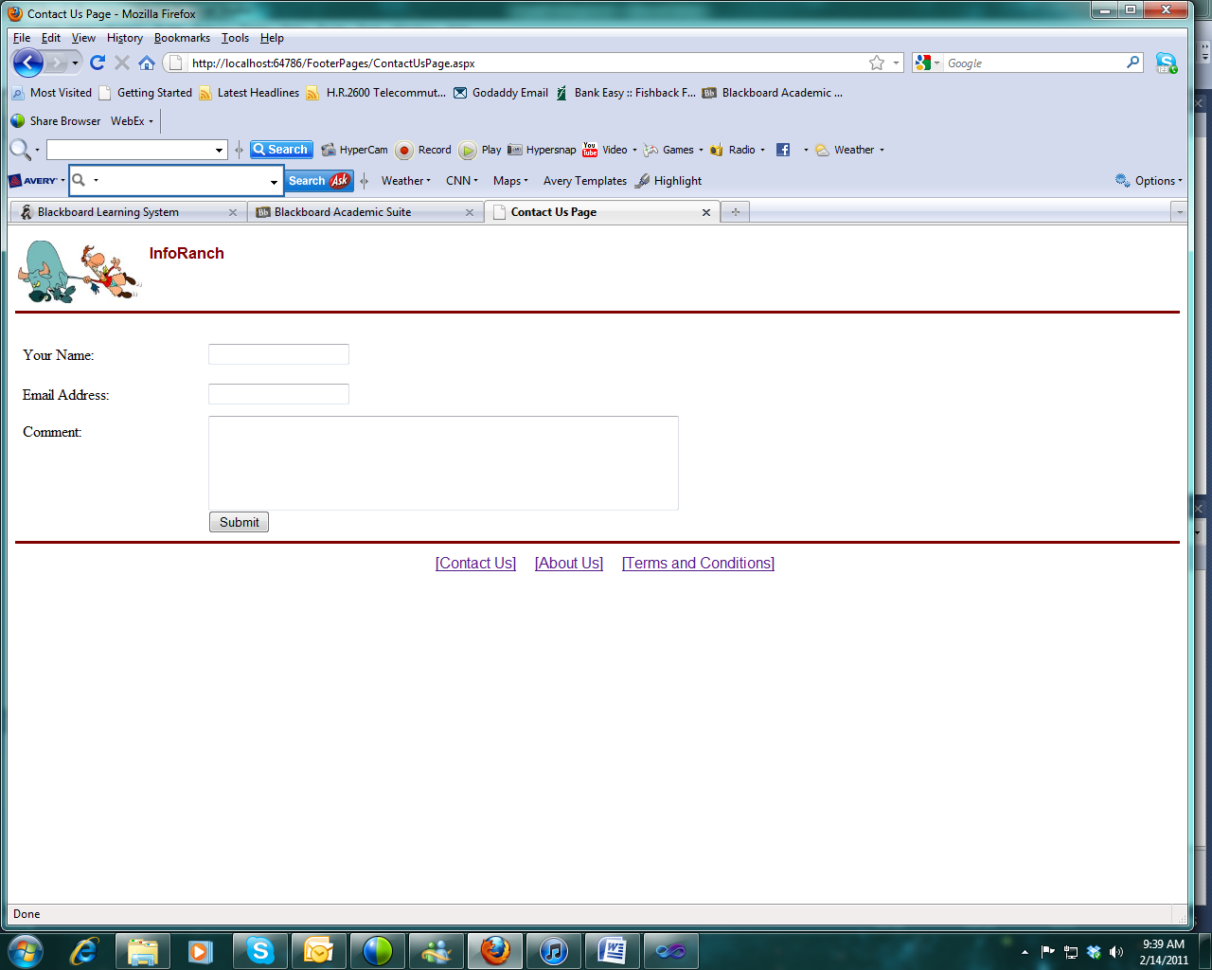

Contact Us Page (Needs some work)

**Logged In**

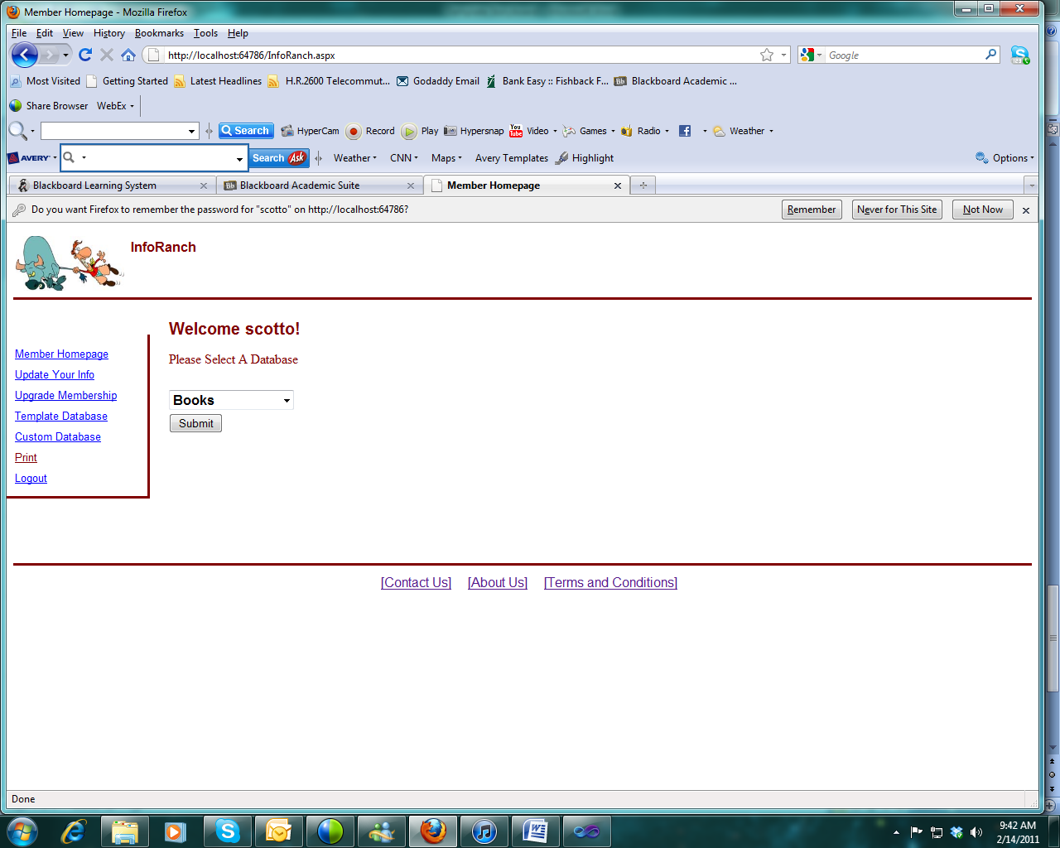

Make a New Template Database

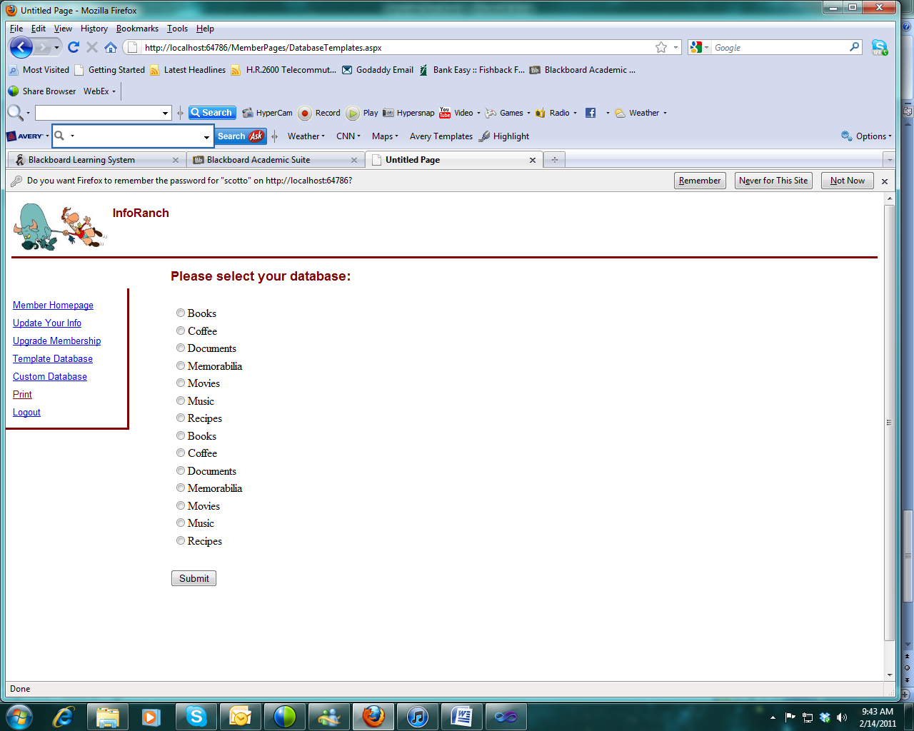

What's Wrong with this Picture?

I picked Movies - What's wrong with this picture?

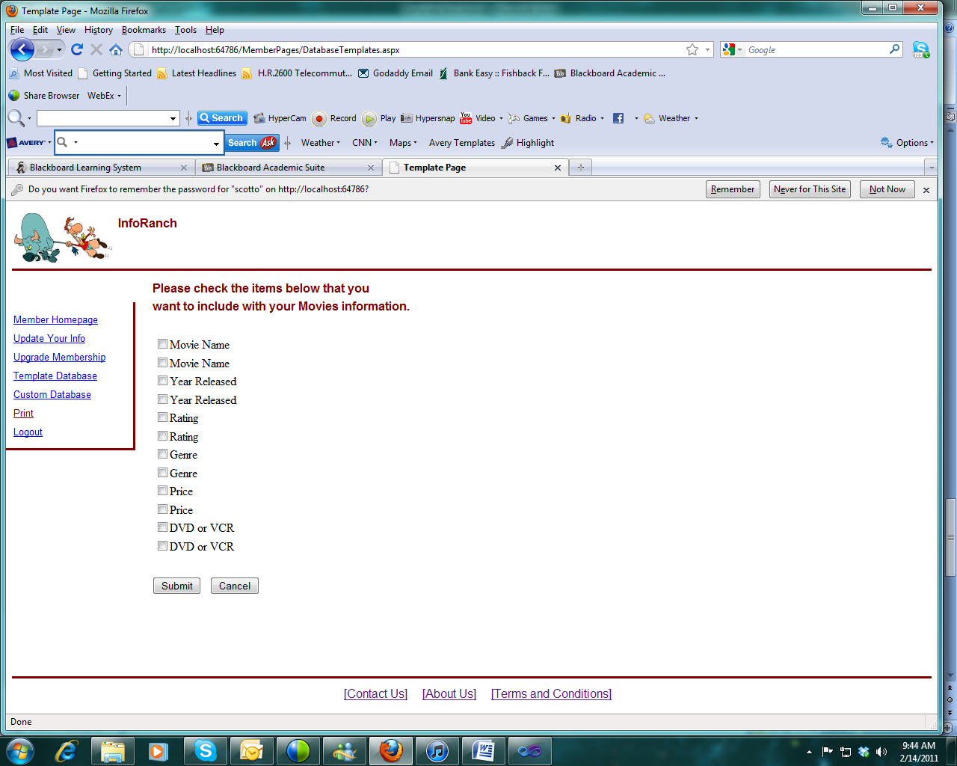

Now I've picked the fields - are there other "standard" attributes of a movie database?

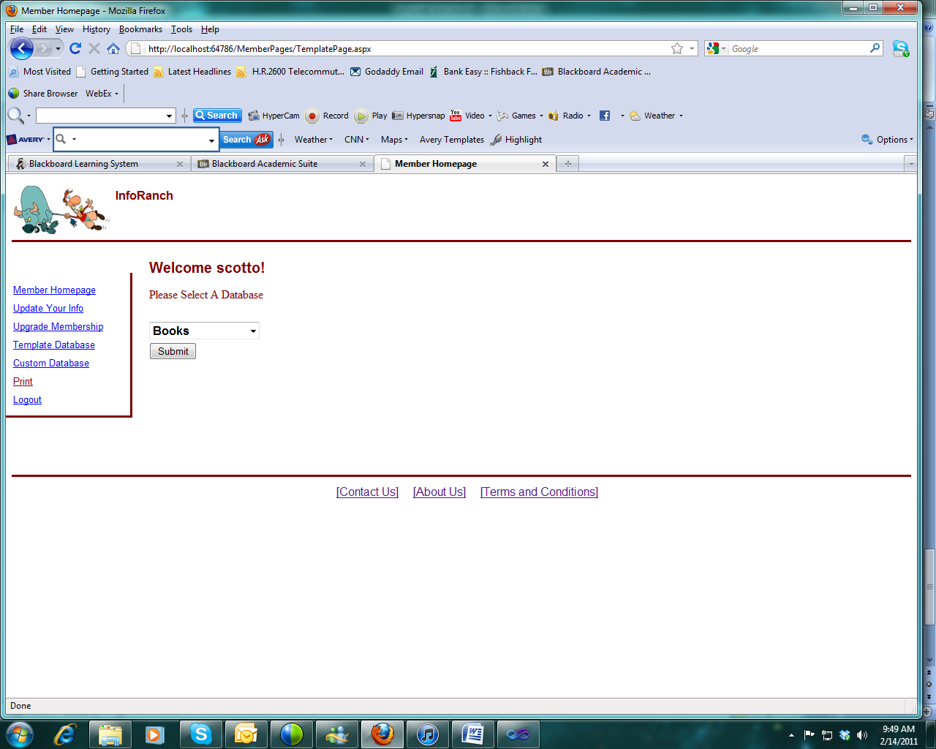

Here's the resulting screen after "Submit" - What's wrong with this picture?

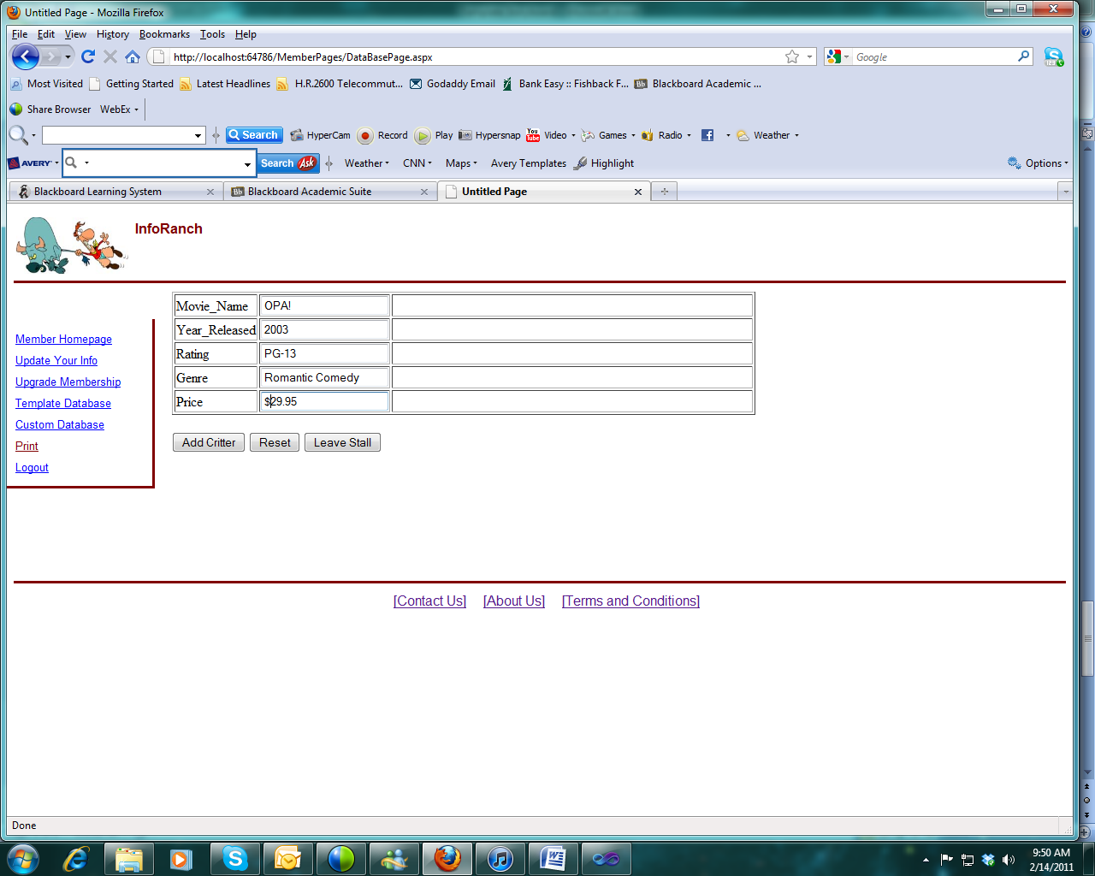

I filled out the form and will now hit "Add Critter". What's wrong with this picture?

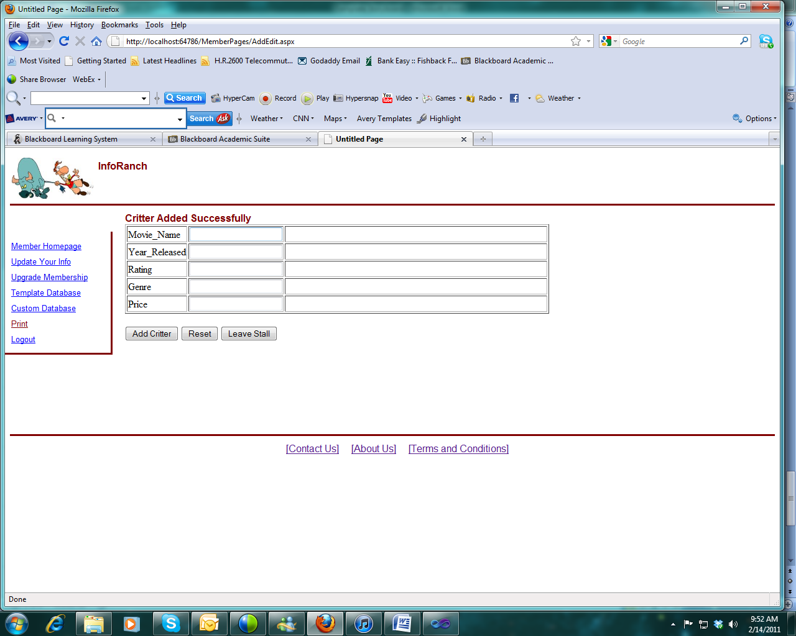

Item added (is this screen okay?)

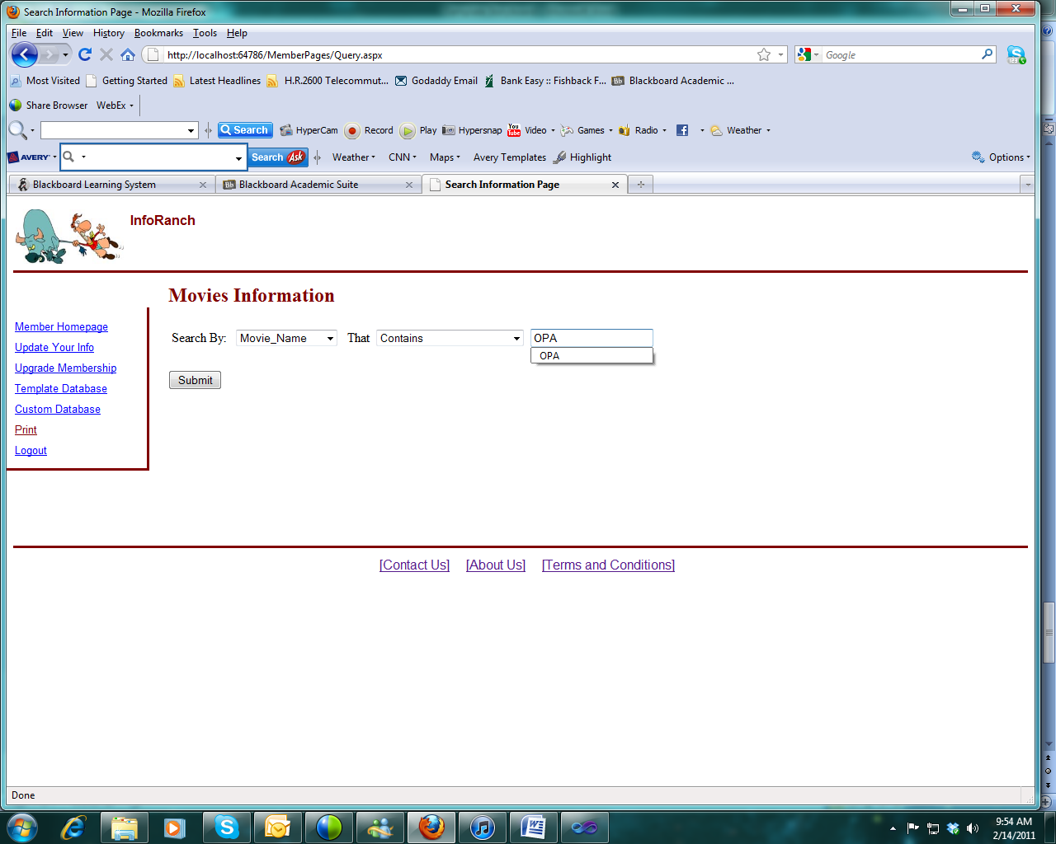

Searching (is this search screen okay?)

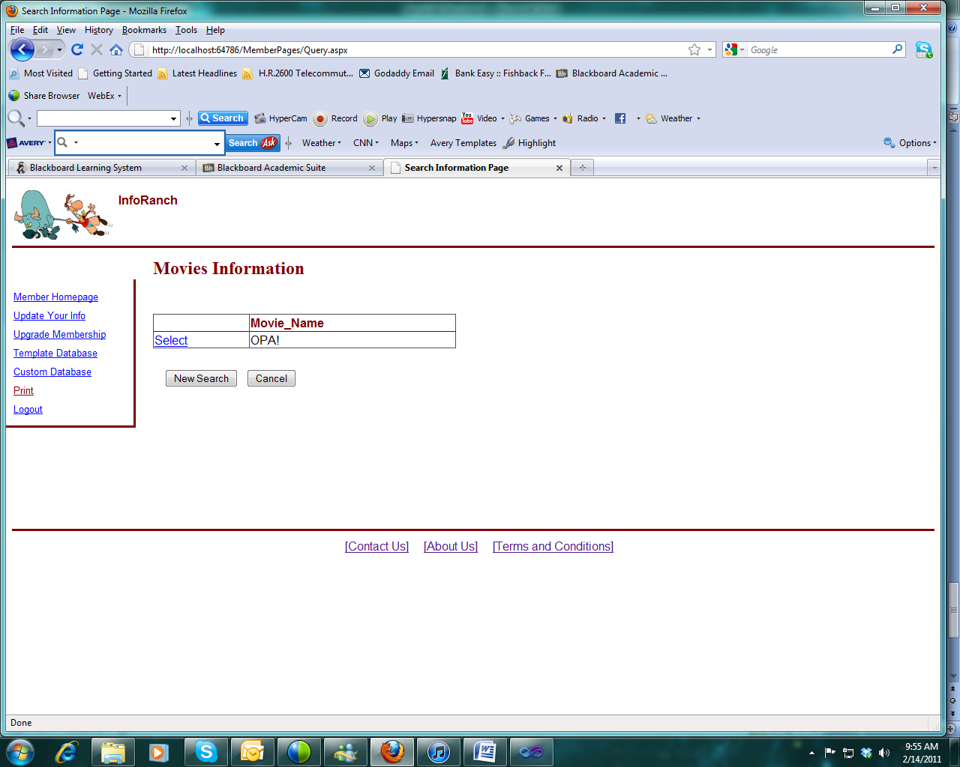

Here's the (accurate) result. Is this acceptable, or should all the fields be shown?

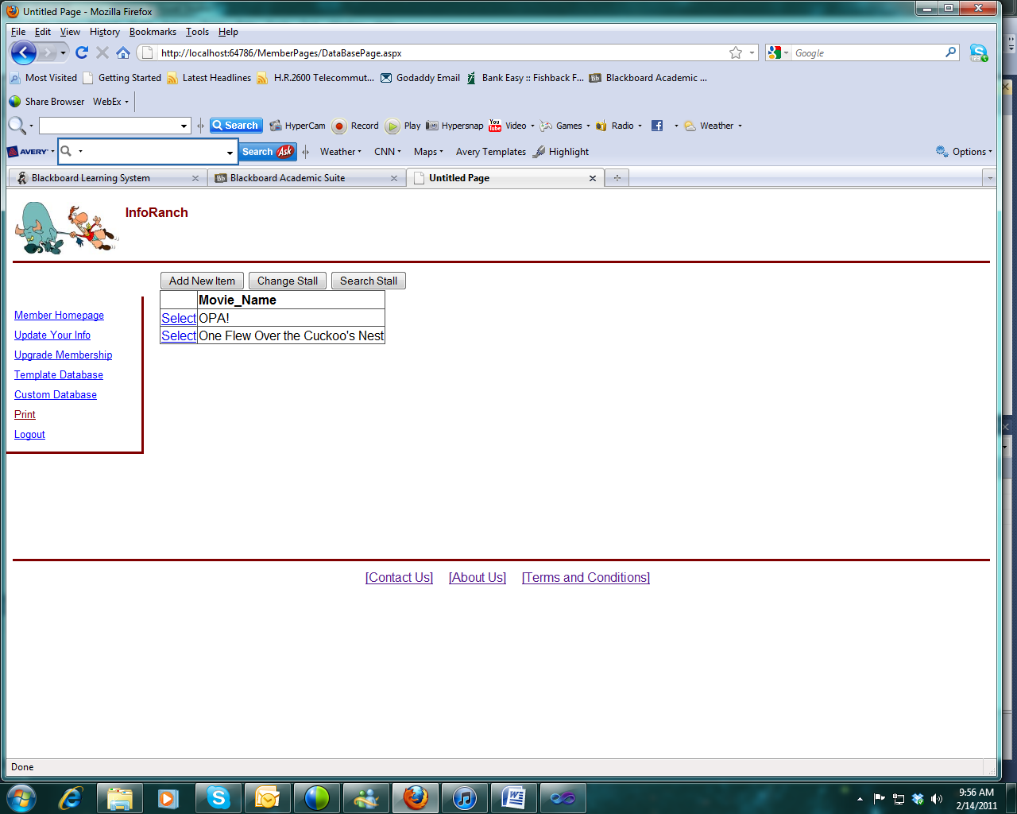

Here's the list of movies in my database. Is there a better way to display this?

This should get you started. If you need additional screen prints, just ask.